## Amal’s Beuaty Lounge is the brand of a unique and truly success story…

## C:\Users\saloon2\Downloads\IMG_7717.JPGC:\Users\saloon2\Desktop\HCMS.350SET (a).jpg

Intro:

It’s always love at first sight, with the ***Four Seasons royal*** statues that are a set of four stone [allegorical](https://en.wikipedia.org/wiki/Allegorical) [putti](https://en.wikipedia.org/wiki/Putti), each representing a traditional, temperate [season](https://en.wikipedia.org/wiki/Season#Traditional_season_divisions). These are a part of the [outdoor sculpture](https://en.wikipedia.org/wiki/Outdoor_sculpture) collection of Amal’s Beauty Lounge, located in the heart of Amman.

**Amal’s Beauty Lounge**, sustainable hair salon, makeup & tattoo, spa and nail section and bridal boutique, providing organic, high quality & chemical-free products and services.  Our salon esthetic is made up of artistic, functional designs utilizing marble and piece unique.

**Description:**

At amal’s beauty lounge we feel that it is as important to nourish the hair and skin, as it is to nourish the body and mind. To achieve this, we offer the highest level of salon service while consistently updating our efforts to find new sustainable ways to be green and giving back to our community and make a real difference in our neighborhood, city, and country. This place is much more than just a great place to get a great haircut.

We specialize in all kinds of hairstyles for women of all ages. Modern haircuts, retro hairstyles, brushing, curling, hair coloring and hair-dos.

We understand and promote the importance of excellent customer service and it is fundamental to our core values. We treat all clients with honesty, respect and fairness, in order to meet and exceed their expectations. Our salon is friendly and welcoming, which makes your visit a more enjoyable and relaxing experience. We appreciate that everyone leads busy lifestyles and we are Committed to keeping our clients looking and feeling their best!

***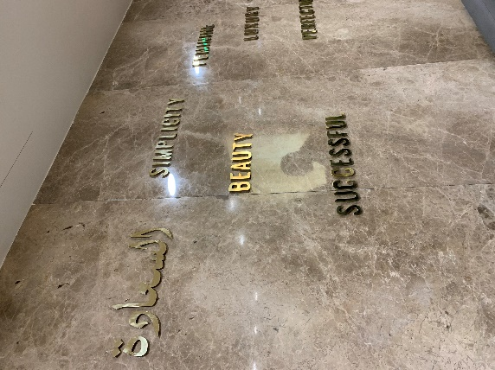***

***Happiness, Simplicity, Beauty, Success, Feminine, and Luxury.. are the definition of our mission!***

**Mixed & Women Only Hair Sections:**

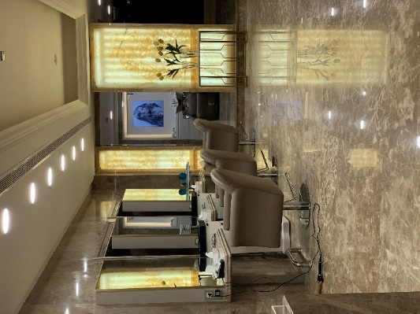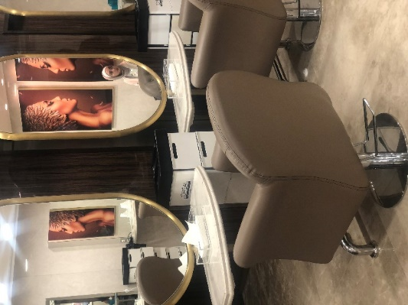

Amal’s Beauty Lounge consists of two separate hair salons, one for women only \*Muhajabat\* and the other is the mixed section, each section is 300 square meters.

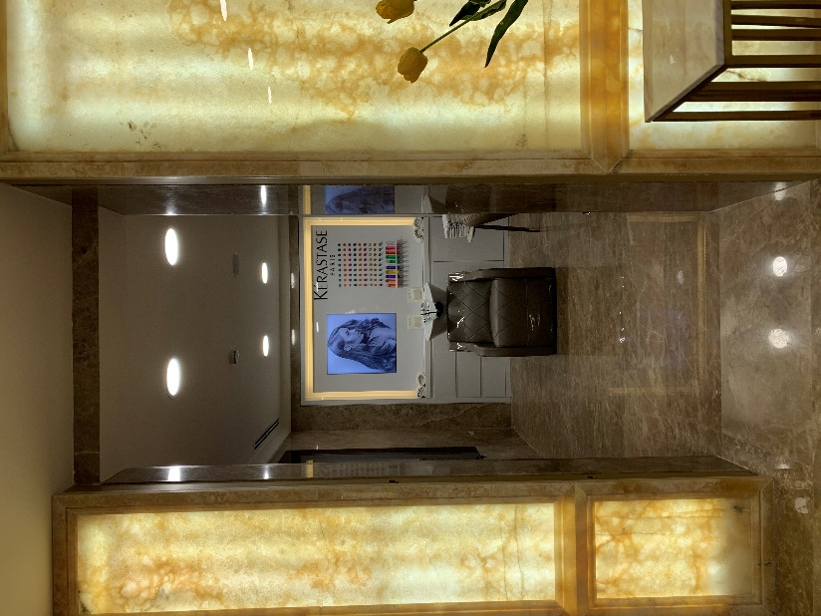

Our special hair treatments room is where your hair will feel live again! It’s an isolated room that we use a variety of high-end hair products, providing a therapeutic, stress relieving head massage while your hair soaks up a beneficial, hydrating mask remedy.

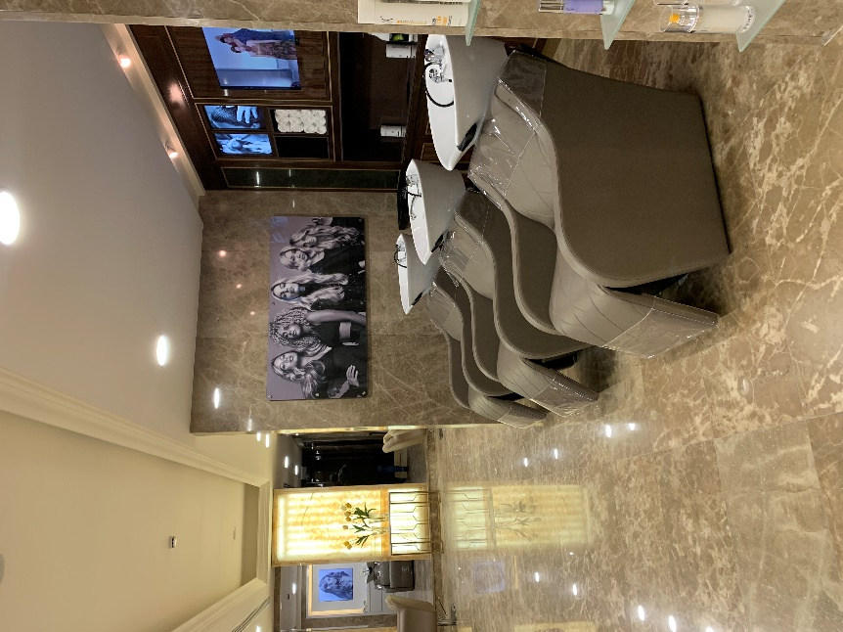

Our one of a kind hair wash and massage chairs are shipped from Italy exclusively to Amal’s hair salon! Thanks to Loreal for these very unique wash units From Maletti. It’s a full body massage while she’s doing a hair mask treatment or just washing her hair.

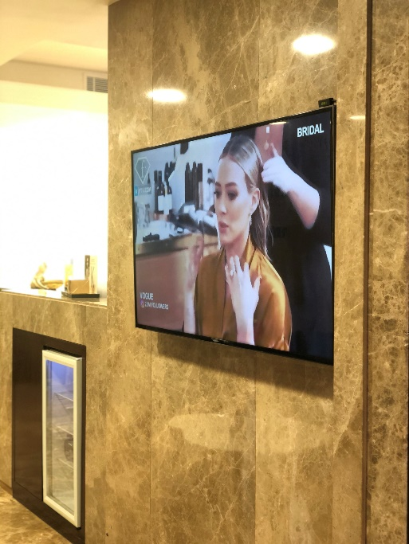

5 Smart TVs are spread in women and mixed sections for our services’ advertising and other sponsored content.

**Products**:

All of our products and services are free of harmful toxins and chemicals, so that our clients can be beautified from the inside out, and can have peace of mind that their health is always a priority with us, as well as their beauty and look.

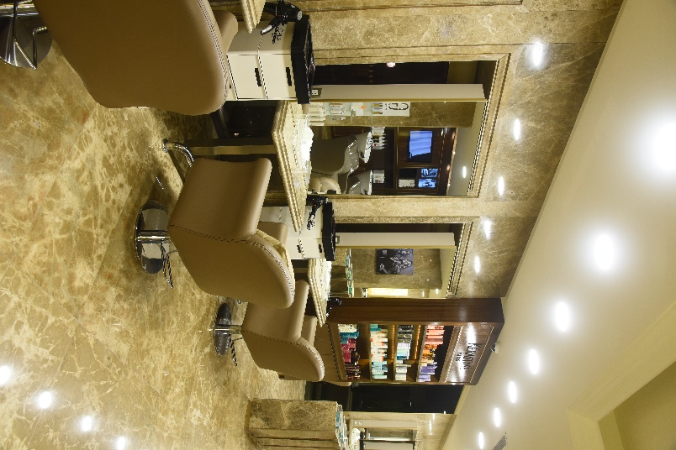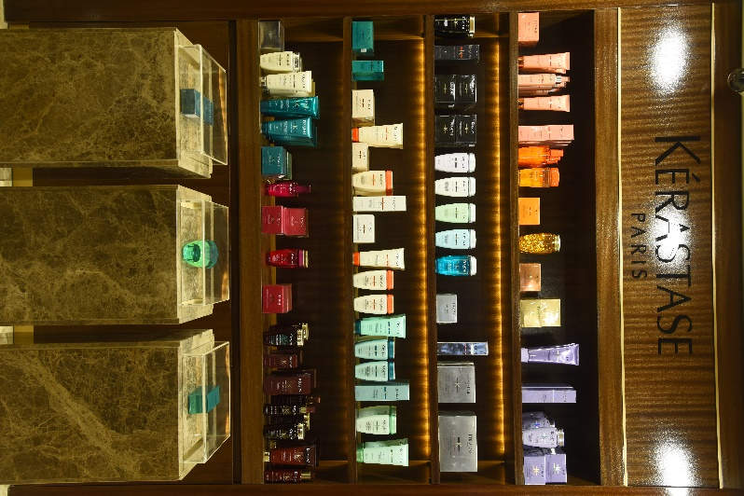

Kérastase is a French luxury hair care line that distributes products internationally. It is part of the L’Oréal Professional Products Division. Kérastase sells hair care and styling products at luxury salons only.

We are the first in Amman to be partnering with Kerastase Officially. We offer a wide range of Kerastase sets and for all hair types all around the year.

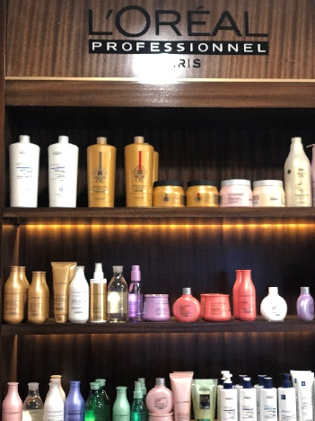

We are also proud to be working in partnership with the world's largest cosmetics company that has developed activities in the field concentrating on hair colour, skin care, sun protection, make-up, perfume, and hair care. L’OREAL – Paris.

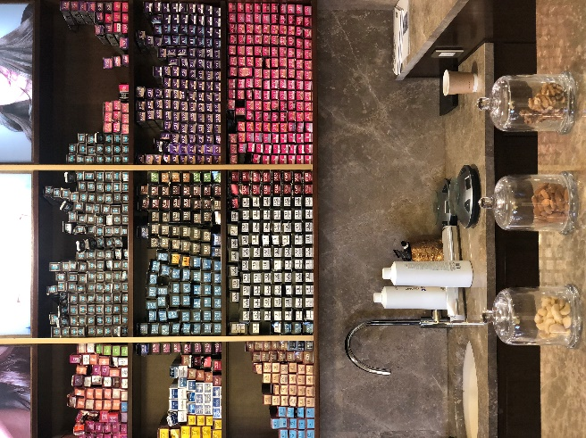

Inoa hairdye, the leading NO AMMONIA permanent hair color range with oil delivery system technology, for all hair types, for pregnant women and sensitive scalps. Achieve your desired hair color that is free from ammonia with the expertise of our hairdressers!

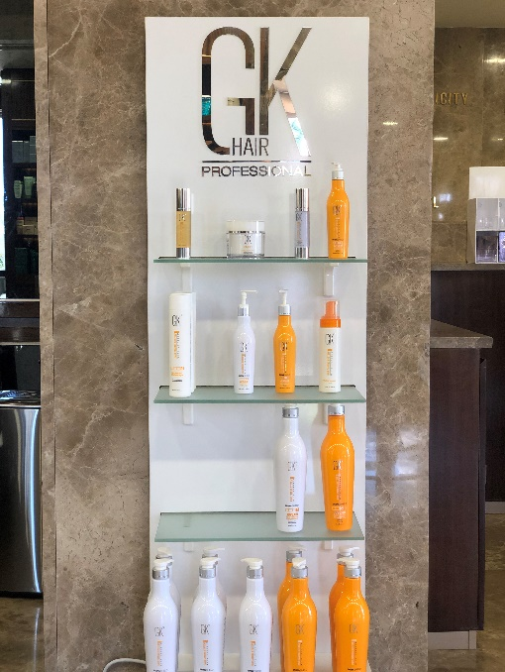

Adding to the list THE GK Hair Professional products’ area. It is one of our best selling hair products and in-salon treatments. GKhair is the first and only company to harness the beauty benefits of Juvexin. Derived from sheep wool through an environmental-friendly process, Juvexin is delivered to the hair in its natural state.

**TEAM:**

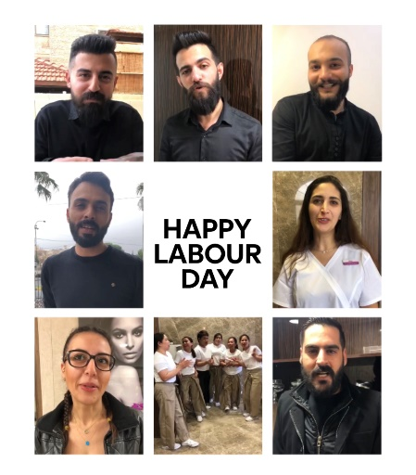

We’ve also attracted some of the most talented stylists to bring you a ‘dream team’ who are attracted to our fantastic culture and superb reputation. We have 11 hardworking men at the mixed section, and 14 talented women at the Mohajabat section.

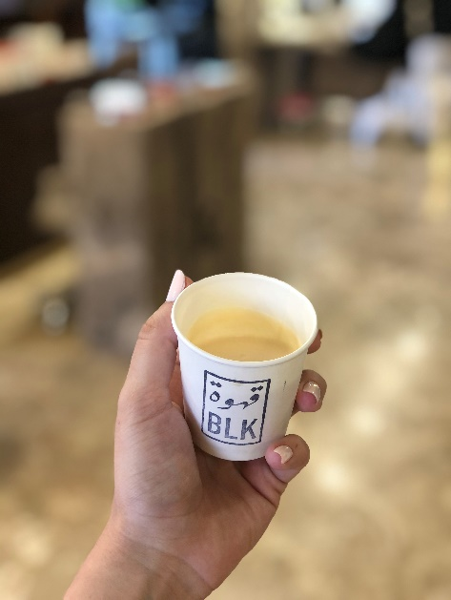

Our Clients also really love the complimentary refreshments of organic coffees and teas, and welcome drink that are offered with every service, in addition to our seasonal fruits and desserts along with the healthy raw nuts. A warm hospitality that creates a family vibe.

We work every day to keep getting better, that is our guarantee! So give us a call or come check us out, because in the end, we only regret the chances we didn't take.

Look Good. Feel Good. Be Good. We are Amal’s Beauty Lounge.

Meet our Friends

Sponsors & more...

Photos

Services

Meet our Team